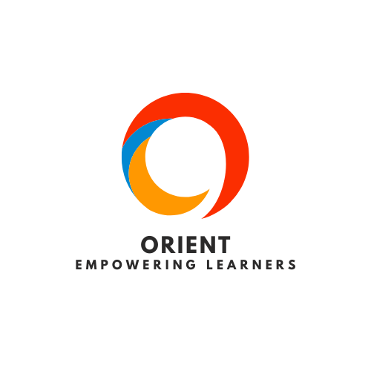

# Orient

**SDG-4** **Quality education**

Concept Note

*Ashutosh Rath, Kartik, Shubhajeet, Yash Wahi*

*August 2025*

Objective

To empower freshers and beginner developers with an AI-powered assistant that helps them choose the most appropriate tech stack (frameworks, languages, databases, and hosting tools) based on the type of software they want to build. The goal is to reduce decision fatigue, streamline their learning path, and promote project-based learning, aligning with the UN Sustainable Development Goal 4: Quality Education.

Problem Statement

In the current digital learning environment, students are often introduced to programming languages without proper context on how to use them in real-world projects. Many beginners find themselves confused about what frameworks or stacks to use for building applications like e-commerce sites, chat apps, or portfolios. They rely heavily on scattered resources like youtube tutorials, Reddit threads, or college seniors’ suggestions. These approaches are often inconsistent, overwhelming, or outdated, leading to wasted time and poor learning outcomes. There is a need for a clear, beginner-friendly tool that gives structured, trustworthy, and personalized guidance.

Proposed solution

Orient is a simple, interactive assistant (CLI, web app, or chatbot) that takes a user’s project idea or interest as input and provides a curated recommendation of the most suitable tech stack to build it. For example, if a user says “I want to build a portfolio site,” the agent may recommend HTML/CSS/javascript with Netlify hosting. It may also include optional filters like preferred language (e.g., Python only), level of difficulty, and hosting budget. Each recommendation will be backed by quick- access resources such as documentation, youtube tutorials, or github examples. Over time, the agent can be extended with GPT-powered responses, personalized learning plans, or integration with coding platforms.

Target audience

* College students in their first or second year
* Self-taught programmers and coding bootcamp learners
* Hackathon participants looking for quick-start stacks
* Developers looking to try new project types but unsure where to begin

**Ashutosh Rath, Kartik, Shubhajeet, Yash Wahi Concept Note**

Expected Outcomes

* Increase in student-led technical projects
* More confident, self-directed learning journeys for freshers
* Time saved by reducing stack-related confusion
* Broader awareness and adoption of modern tech tools

Implementation plan

* **Phase 1**: Build a prototype with a fixed recommendation logic (rule-based) and keyword matching
* **Phase 2**: Add search-friendly UI (CLI, Streamlit, or web interface)
* **Phase 3**: Expand stack database, add filters, and allow user feedback

Sustainability and SDG alignment

This project supports SDG 4 (Quality Education) by making technical education mo- re accessible, structured, and practical. It empowers students through self-guided, project- based learning, and bridges the gap between learning syntax and building real-world applications. Over time, the system could be scaled to support multiple languages, di- verse regions, and educational partnerships.

Estimated Costs

Minimal costs for prototyping. Future costs may include hosting (if web-based), Openai API (if GPT is used), and basic marketing to reach student communities.

Revenue Streams (Long-Term Vision)

The project can later monetize via a freemium model—free for basic use, paid for personalized mentoring or integrated GPT-powered learning paths. Partnerships with edtech platforms or developer communities are also viable.

Conclusion

Orient is a scalable, practical, and timely solution that helps bridge the gap between theory and practice in software development education. By focusing on beginner-friendly recommendations and removing barriers to project-building, it fosters confidence, creativity, and self-directed learning in the next generation of developers.